Aim:
To determine the critical buckling load of a rectangular column using Eigenvalue Buckling analysis in ANSYS Workbench.
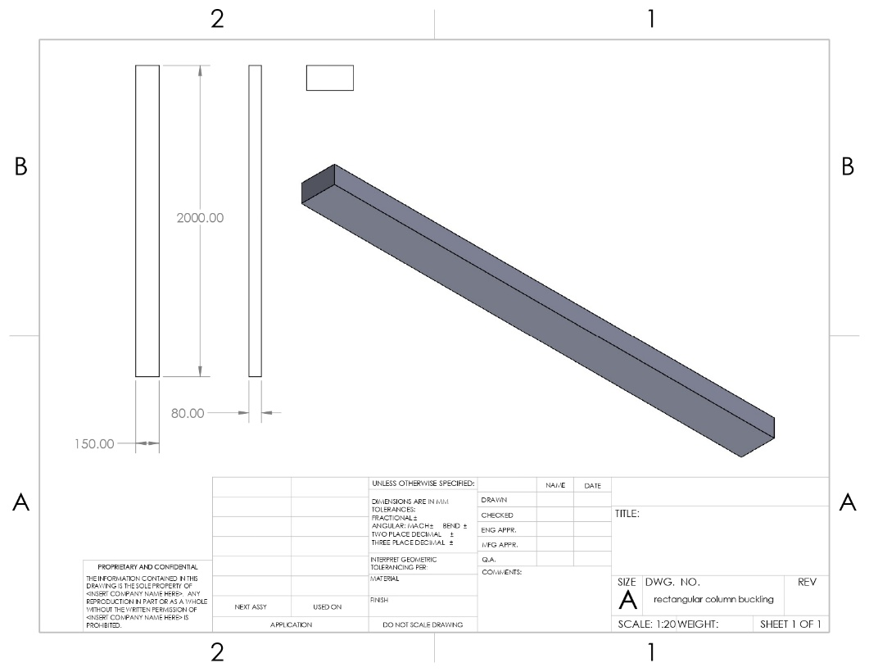
One end – fixed
Second end – free
Force = 1000 N

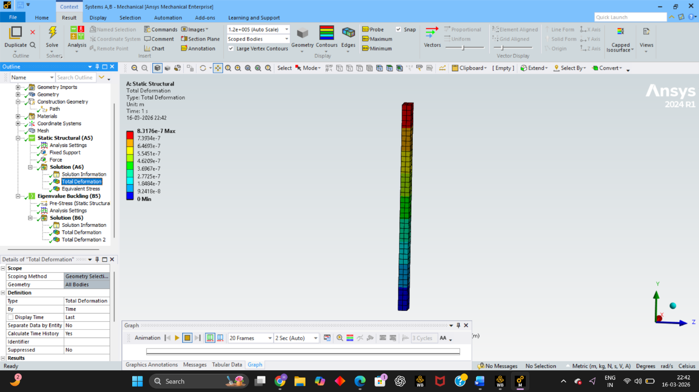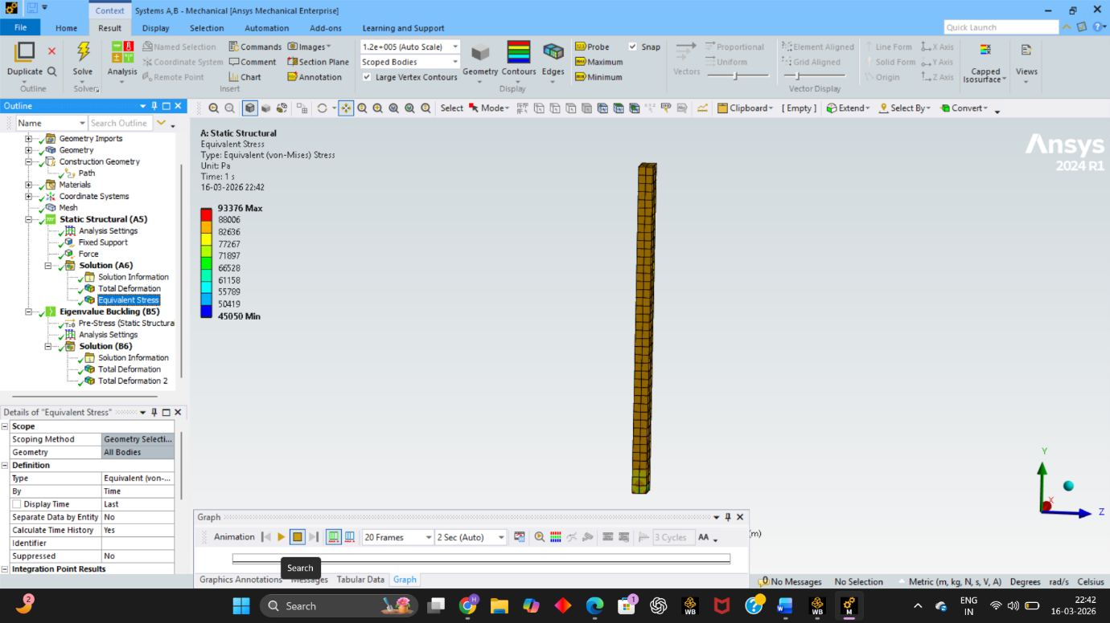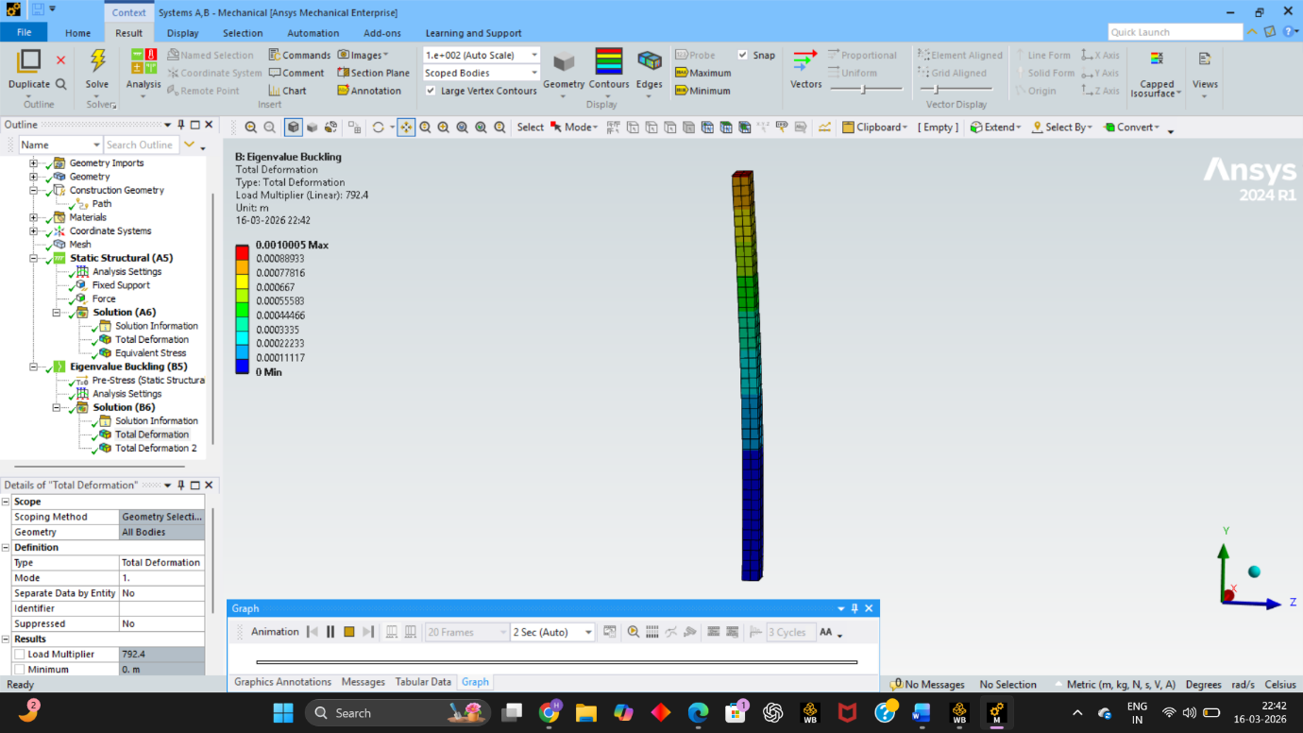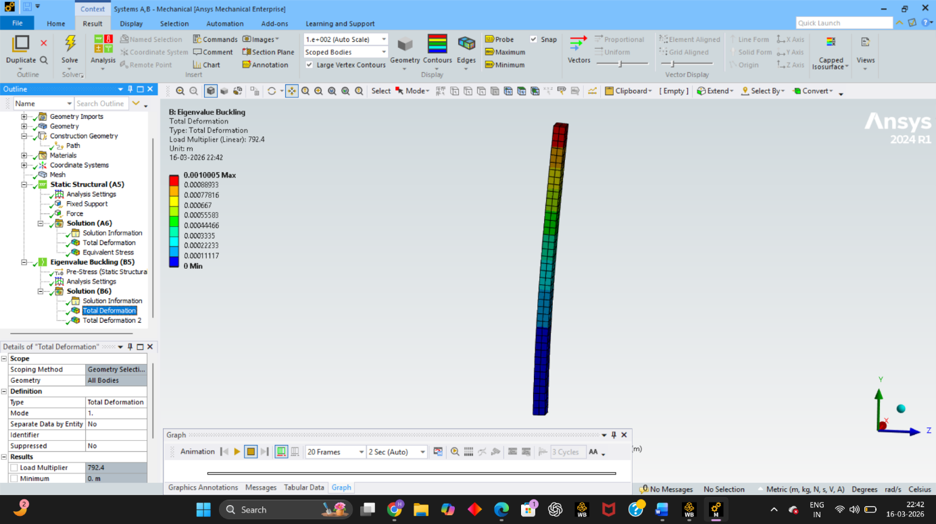
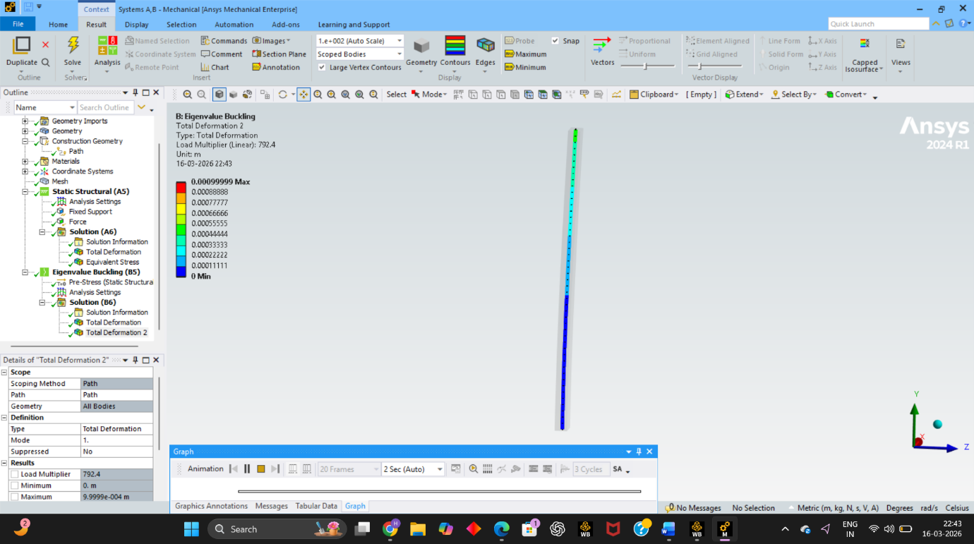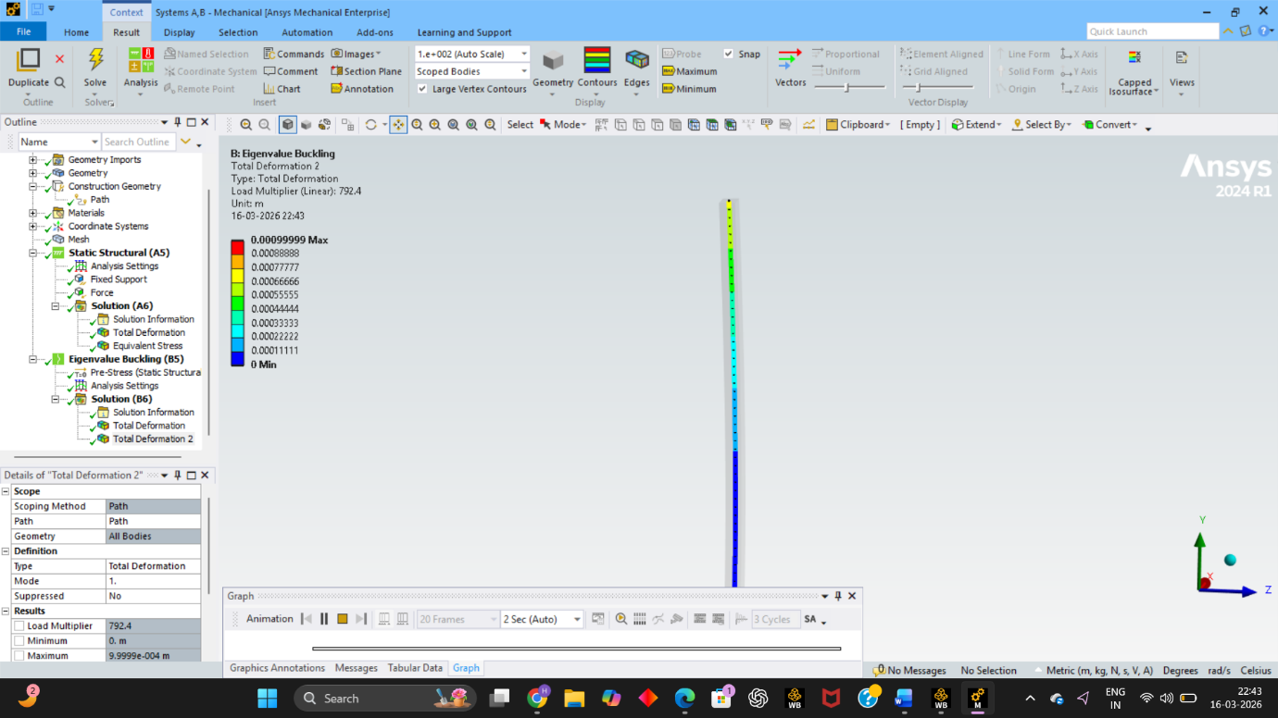
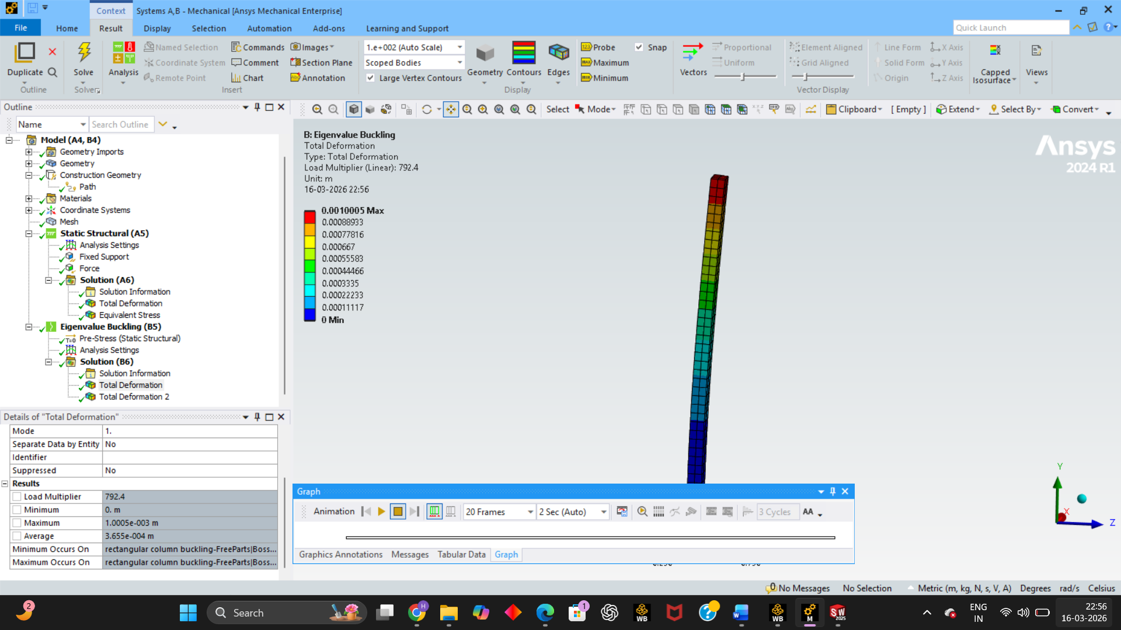
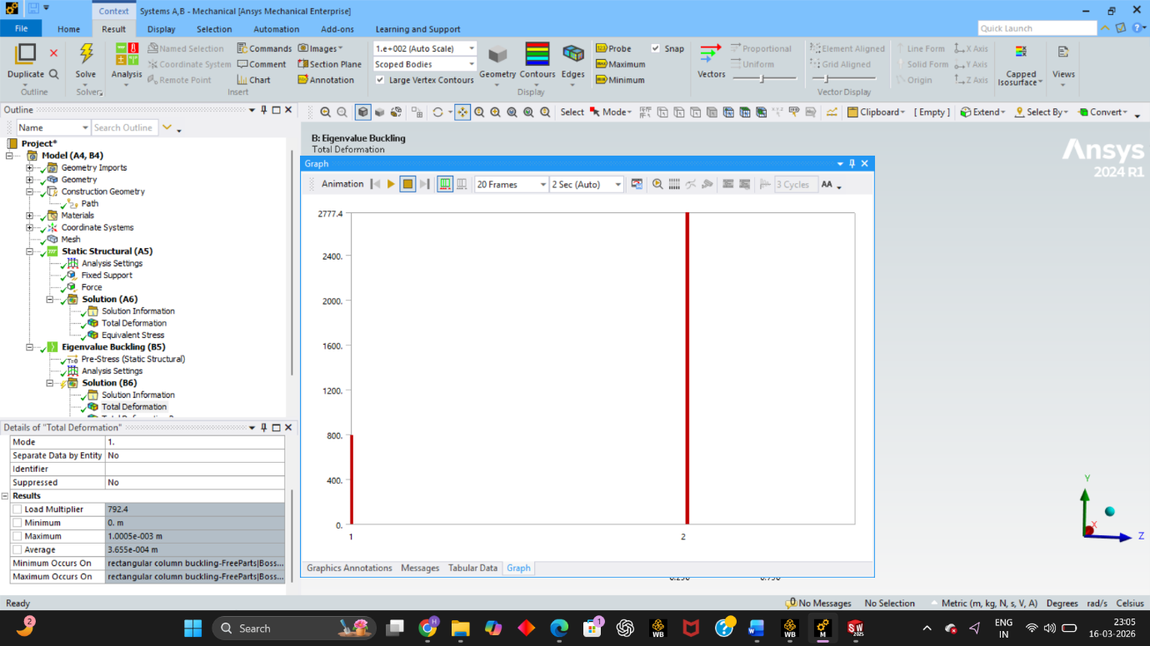
P_{(critical) at mode 1} = load multiplier x force = 792.4 x 1000 = 792400 N
= 792.4 KN
P_{(critical) at mode 2} = load multiplier x force = 2777.4 x 1000 = 2777400 N
= 2777.4 KN
Mode | Theoretical (kN) | ANSYS Results (kN) | Error (%)
Mode 1 Critical Load | 789.5 | 792.4 | 0.36
Mode 2 Critical Load | 2775.8 | 2777.4 | 0.05

